Graphics I - Lab 5

Objective

Today’s lab will work on the assumption you have completed lab 4. We will be introducing the depth buffer and texturing in this lab. You can use your existing lab 4 as a base, just make sure to create a new project.

The depth buffer will be introduced to you today. It will essentially be similar to a color buffer except the difference is it holds depth information. Before we draw a pixel we must determine if that pixel has already been drawn to. We determine this by inquiring the value of the depth buffer at that specific pixel location. We will need to modify our pixel drawing function to include depth information of the specific pixel in order for the depth buffer to be used properly.

The other portion of today’s lab will consist of UV coordinates for texturing. As explained in lecture these UV coordinates range from 0 to 1 on both the width and height of a texture. You should include this information in your VERTEX structure.

1. Let’s setup our depth buffer. It will have the same size of our color buffer, but the initial values will be set to a certain value. **HINT**: this was talked about in lecture.
2. Modify our pixel drawing routine to involve the use of this new depth buffer. The first thing we must do is add another parameter that involves the depth value of this pixel we want to process.
3. We calculate the depth by using the z value of our vertex. **HINT**: we need to find barycentric coordinates in order to find this depth value.
4. Once the depth information is found, we check this value against the value in our depth buffer. If this calculated value is **farther** than what is currently in the depth buffer, then we do nothing. If this value is **closer** than what is currently there, then we draw this new pixel.
5. To find the UV coordinates, we will need barycentric coordinates again. This new calculated value will be the x and y into our texture array. Similar to what we did in the first lab with blitting.
6. Once we have done all the setup. It’s time to start drawing. (The 25% and 50% mark do **NOT** use the depth buffer or uv information. If you haven’t completed Lab 3 or Lab 4, I suggest you go ahead and complete the necessary portions in order to get this step done.
7. The 75% mark uses the depth buffer but does **NOT** use the UV information.
8. The 100% mark uses the UV information.

Grade Breakdown

The grading breakdown for this lab will be split up into 4 portions.

* 25% - Change the current window size. Ensure that it is not completely square.
  + Doing this will affect the projection matrix.
* 50% - Draw the cube with colored triangles
  + Different colors per face, No depth information included
* 75% - Add the depth buffer to the scene.
* 100% - Texture the cube (make sure UV coordinates are part of the VERTEX information)

Example Images

**25% 50%**

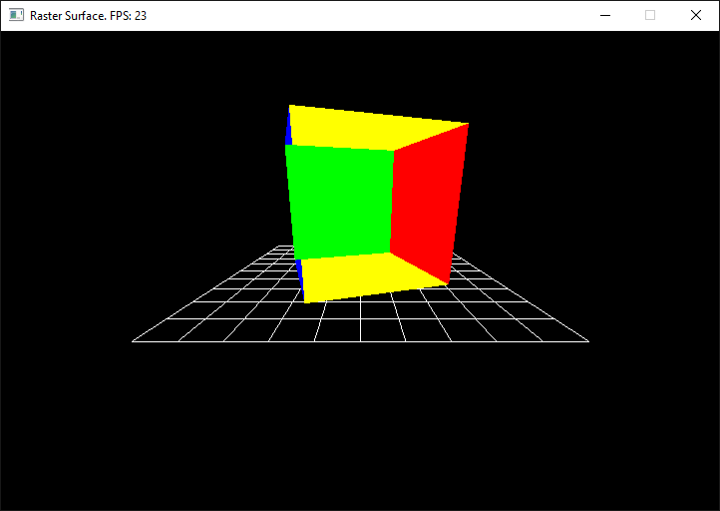

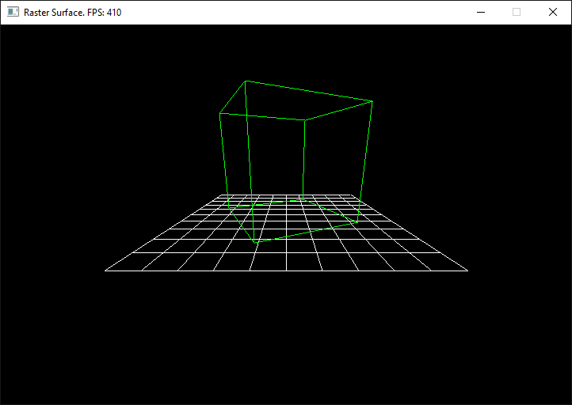

**75% 100%**

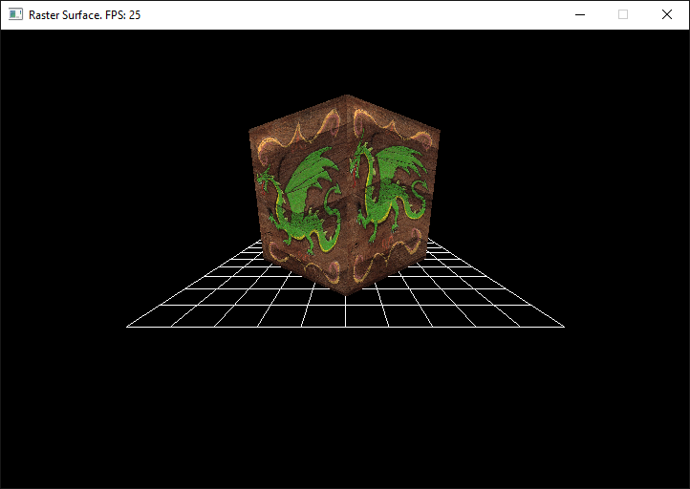

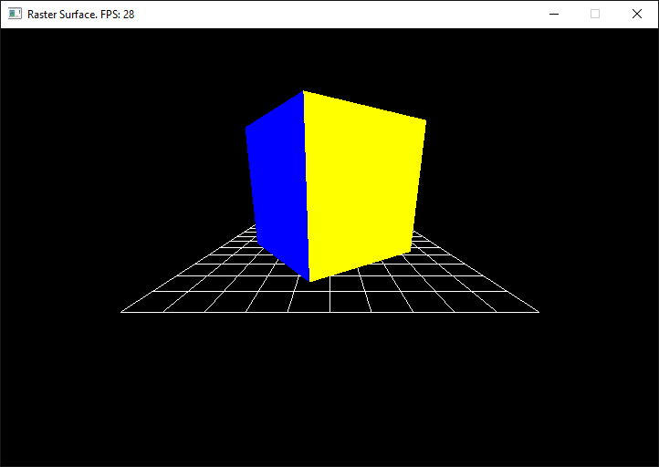

Submission

Labs will be turned in to … in the format of a zip file. The naming convention for the file will be ***Lastname.Firstname.Lab5.zip***. The contents of your .zip file should ***only*** be your source files that ***you*** wrote. We would like this submission to be as small as possible in order to accommodate space for everyone’s submission. If you fail to submit properly *you will lose points* on your grade.

Above & Beyond

1. Showcase the accuracy of your new Z buffer by drawing a secondary smaller cube intersecting the main one. Be sure to use a different texture.
2. Modify your pixel shader’s texturing operation to support UV’s beyond 1 and below 0. Modify the UVs on the cube to go from -1.0 to +2.0 on each face. The image should appear to repeat across each face of the cube 3 times.

Frequently Asked Questions